Acceptance Test Procedure Specification (ATP)

*VeriStand 1553 Driver*

Viewpoint Systems, Inc.

800 West Metro Park

Rochester, NY 14623

|  |  |  |  |
| --- | --- | --- | --- |
| **Document No.** |  | **Current Revision** | **-** |
|  |  | **Authors** |  |

|  |  |
| --- | --- |
| **Intended Approver Name** | **Title / Organization** |
|  |  |
|  |  |
|  |  |
|  |  |

|  |  |  |  |
| --- | --- | --- | --- |
| **Rev.** | **Description of change** | **ECN #** | **Date** |
| A | Initial Release |  |  |

Table of Contents

1. Introduction 5

1.1 Purpose 5

1.2 Definitions, Acronyms, and Abbreviations 5

1.2.1 Acronyms and Abbreviations 5

1.2.2 Definitions 5

1.3 References and Links 5

2. Overall Description 5

2.1 Product Perspective 5

2.2 Requirements for Product Use 6

2.2.1 Software 6

2.2.2 Hardware 6

2.3 Theory of Operation 7

3. Acceptance Test Procedure 7

3.1 System Definition 7

3.1.1 Database Support 7

3.1.2 Channel Definition 8

3.1.3 Channel Configuration 9

3.1.4 Channel Save/Recall 9

3.1.5 Channel/Bus Support 10

3.2 RT Driver 11

3.3 Major Frames 11

3.4 Buffer Depth 11

3.5 Message Support 12

3.5.1 The driver shall support BC-RT messages 12

3.5.2 The driver shall support RT-BC messages 12

3.5.3 The driver shall support RT-RT messages 12

3.6 Acyclic Frames 13

3.7 Errors and Status Support 14

3.8 Data Timestamps 15

3.8.1 Timestamping shall return the time in seconds (U32) and fractional microseconds (U32) 15

# Introduction

This document contains the acceptance test procedure for the VeriStand 1553 driver that supports the AIT 1553 interface card for use in National Instruments Real-Time PXI platform.

## Purpose

The purpose of this Acceptance Test Procedure (ATP) is to verify that the requirements of the driver have been implemented and function properly.

## Definitions, Acronyms, and Abbreviations

### Acronyms and Abbreviations

AIT – Avionics Interface Technologies, Inc

VSI – Viewpoint Systems, Inc

### Definitions

MIL-STD-1553

<http://en.wikipedia.org/wiki/MIL-STD-1553>

## References and Links

[www.aviftech.com](http://www.aviftech.com)

[www.viewpointusa.com](http://www.viewpointusa.com)

# Overall Description

## Product Perspective

For users of VeriStand, this driver provides a way to interface with the MIL-STD-1553 avionics bus using AIT 1553 hardware. VeriStand is a system used for HIL applications and is a configurable system rather than a programming environment. No programming is necessary to use VeriStand to interface with the 1553 hardware. Although the driver is intended for use in the RT environment (tested with RT), it can be used in a non-deterministic windows environment.

## Requirements for Product Use

### Software

This device was created for use with NI VeriStand 2013.  To use this custom device you must have the following software installed:

* NI VeriStand 2013 or later
* NI-VISA
* AIT MIL-STD 1553 LabVIEW Driver 2.37.0 or later
* The download provided with this Add-On

### Hardware

This driver was tested with the following hardware:

* NI PXI-RT Controller and Chassis
* AIT PXI-C1553-2 (or similar)

## Theory of Operation

This driver is an in-line custom device that launches five parallel loops (for TX and RX on each sub-section: BC, BM, RT) and communicate to/from them with RT FIFOs. The in-line portion going at the NIVS rate does no driver calls; it just reads and writes the RT FIFOs. At initialization the custom device uses the Minor Frame rate of the BC and sets the loop rates for BC, BM, and RT to twice that speed. Data read from the hardware is passed back to the inline driver through the RT FIFOs and similarly, data for output is passed to the asynchronous loops through RT FIFOs. Two buffers (In and Out) are used to manage the data coming from/going to the FIFOs.

# Acceptance Test Procedure

This test procedure expects the pre-existing files are in place to support the test procedure. It is also assumed that the hardware is installed and configured properly for operation.

* Test 1553 with Acyclic – SIM RT.nivssdf
* Test 1553 with Acyclic RTRT SIM RT.xml
* Test 1553 with Acyclic RTRT SIM RT-Parameters.txt

## System Definition

### Database Support

Requirement Reference SRS 3.1.1

Instructions

1. Open system definition file.
2. Add 1553 Device to system definition
3. Enable Bus 1

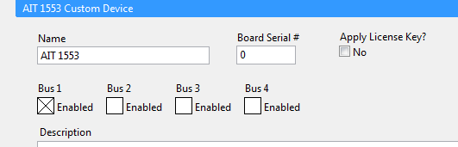

1. Select the Bus “BusName1”
2. Right Click on BusName1 and select Load Database
3. Select the file “Test 1553 with Acyclic RTRT SIM RT.xml”

(Note that the associated parameters file will be loaded in with the pre-defined channel definitions)

Expected Results

The selected database is loaded in and each section under the bus (Bus Controller, Bus Monitor, and Remote Terminal) is populated with the configured messages.

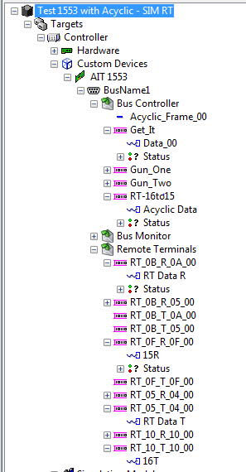

Disposition

Comments

### Channel Definition

Requirement Reference SRS 3.1.2

Instructions

1. Select a message under the bus controller section
2. Right Click on the message and select add parameter

Expected Results

A new channel has been added to the tree. It should be auto-named Data_xx where the xx is the next unique name available.

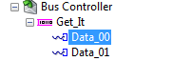

Disposition

Comments

### Channel Configuration

Requirement Reference SRS 3.1.3

Instructions

1. Select channel Data_01 under the Gun_One transmit message in the bus controller section.
2. Set the items in the parameter page as follows:

* First Word = 12
* Start bit = 0
* Number of Bits = 8
* Signed
* Scale Factor = -2
* Offset = 5

Expected Results

The default value transmitted would be - 17

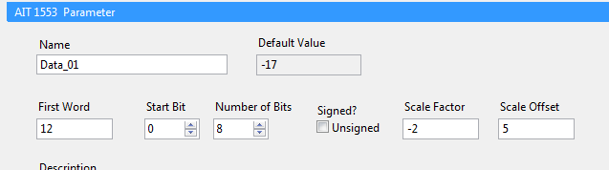

Disposition

### Channel Save/Recall

Requirement Reference SRS 3.1.4

Instructions

1. Right click on the “BusName1”
2. Select Export Database

Expected Results

A text file named the same as the Database is created alongside, with a “–Parameters” suffix added. Upon loading of a Database, if a parameter file is present, the two will be merged.

E.g.

Test 1553 with Acyclic RTRT SIM RT.xml

Test 1553 with Acyclic RTRT SIM RT.xml -Parameters.txt

Disposition

### Channel/Bus Support

Requirement Reference SRS 3.2.2

Instructions

1. Open new system definition file.
2. Add 1553 Device to system definition
3. Select the checkbox for Bus1
4. After the bus is enabled, expand the entry of the device

Expected Results

The three sub-sections under the Bus are added to the custom device tree.

Before:

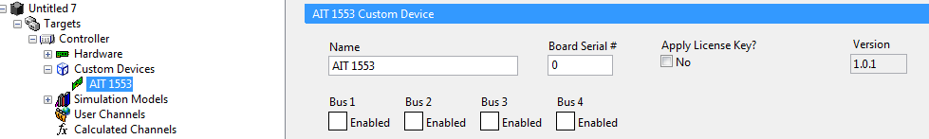

After

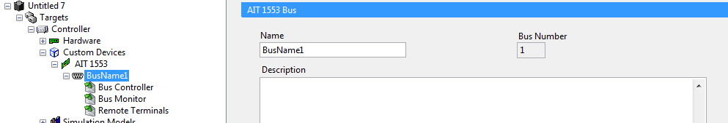

Disposition

Comments

## RT Driver

To test the items in this section, open and execute the system definition file by pressing the green run arrow. All of the following requirements can be verified by virtue of the fact that this system definition executes properly.

## Major Frames

The driver shall support one major frame.

## Buffer Depth

The driver shall support a buffer depth of one (1).

Instructions

This system definition references a flight simulyzer file that contains one major frame.

Expected Results

Successful execution indicates adherence to the requirement. The following image is what the workspace should look like.

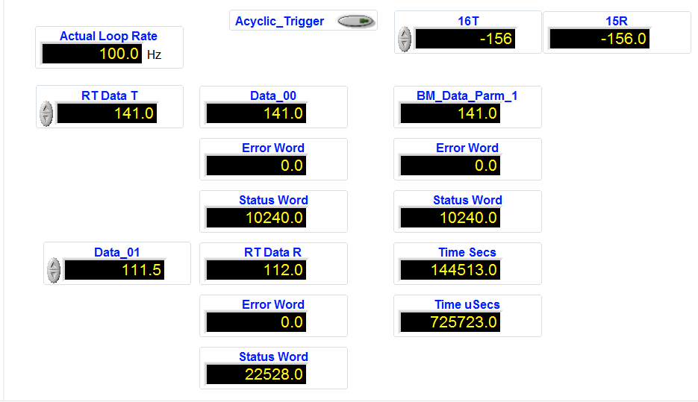

Disposition

## Message Support

### The driver shall support BC-RT messages

Request a BC to RTC Data Change

Instructions

1. Enter the value 28 into the Data_01control.

Expected Results

The value will pass to the RT Data R indicator showing the data in the message was transferred per the flight simulyzer configuration.



Disposition

### The driver shall support RT-BC messages

Request an RT to BC Data Change

Instructions

1. Enter the value 141 into the RT Data T control.

Expected Results

The value will pass to the Data_00 indicator showing the data in the message was transferred per the flight simulyzer configuration.



Disposition

### The driver shall support RT-RT messages

RT to RT Transfer (The BC does not have to see the RT-RT data)

Instructions

1. Enter the value -156 into the 16T control.
2. Press the button “Acyclic Trigger”
3. Observe the value that shows in the indicator 15R

Expected Results

The value will pass from the control 16T to the indicator 15R. The message was transferred per the flight simulyzer configuration. Remote terminals 15 and 16 are defined and an acyclic message that transfers 16 to 15 has been created in the configuration.

Before Trigger

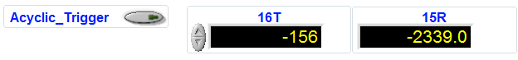

After Trigger

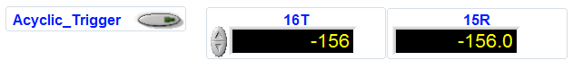

Disposition

## Acyclic Frames

The driver shall support the ability to trigger acyclic messages.

Instructions

1. Enter the value -156 into the 16T control.
2. Press the button “Acyclic Trigger”
3. Observe the value that shows in the indicator 15R

Expected Results

The value will pass from the RT control 16T to the RT indicator 15R. The message was transferred per the flight simulyzer configuration. Remote terminals 15 and 16 are defined and an acyclic message that transfers 16 to 15 has been created in the configuration.

Before Trigger



After Trigger



Disposition

## Errors and Status Support

Error word and Status word are supported on all incoming data items. This includes the following

* Bus Controller

RT-BC – Both Supported

* Bus Monitor

All messages in the BM support error and status words

* Remote Terminals

BC-RT – Supported

Instructions

1. Execute the system definition.
2. Observe the Error and Status fields.

No Error is indicated by a value of zero (0)

Status words are bit-packed fields and can be decoded by looking at the definition in the AIT 1553 quick reference guide which contains field definitions.

Expected Results

Error fields should be zero. Status words as shown.

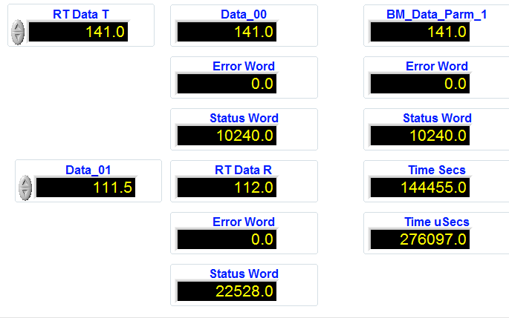

Disposition

## Data Timestamps

### Timestamping shall return the time in seconds (U32) and fractional microseconds (U32)

Only the Bus Monitor returns timestamps of the incoming data.

Instructions

1. Execute the system definition.
2. Observe the Time fields and note the seconds and uSecs incrementing.

Expected Results

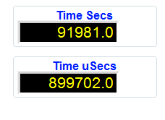

Disposition

Bus Controller

BC-RT – Not Supported

RT-BC – Not Supported

RT-RT – Not Supported

Bus Monitor

All messages in the BM support Timestamping

Remote Terminals

BC-RT – Not Supported

RT-BC – Not Supported